Using the BLE fuctionallity on the Argon

I have created a header file to easily set op the Service and characteristics 

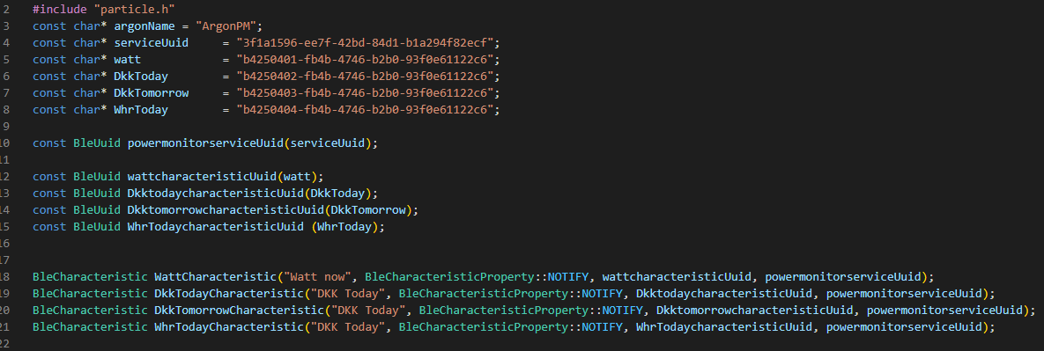

We have 4 different characteristics that we send. Watt, DKKtoday, DKKTomorrow and WhrToday.

They are set to Notify, in notify mode you choose when to send data and the QOS is without reply.

They are assign Uuid (unique identifiers), and these can be generated online with the use of diverse websites. There actual values have no meaning other then being unique.

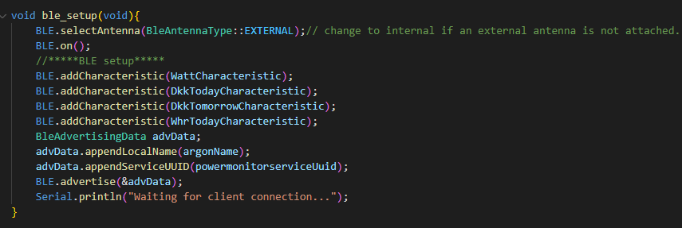

The header file also includes a setup function to setup the BLE.

Select antenna should be changed to internal if you do not have an external antenna. The range of the BLE is much higher with the use of an external antenna.

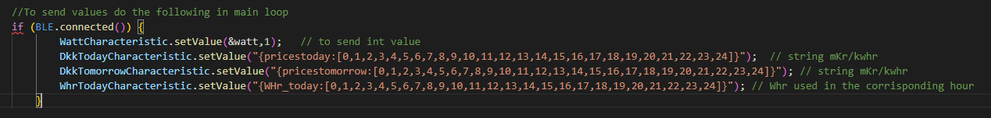

To send values we can first check if there is a device connected.

And set the values with .setvalue

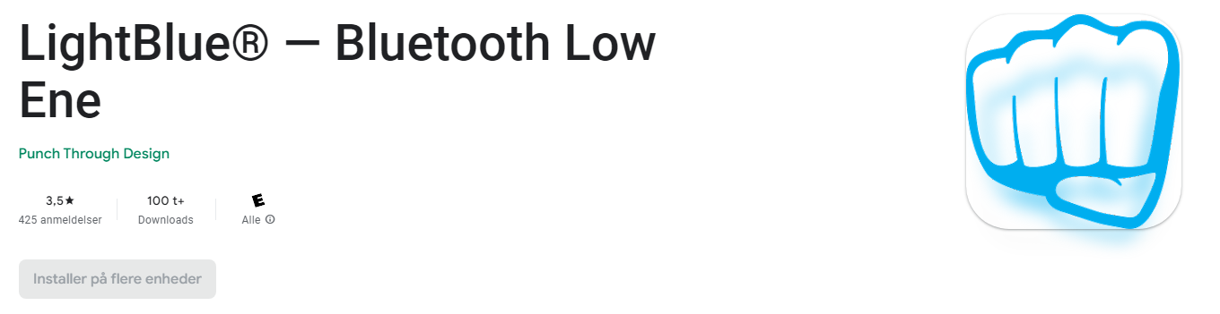

To test the services are set up and that data is being broadcast I have used an app called lightblue.

When the Argon is powered on and you open the app you should see a device with the name “ArgonPM”

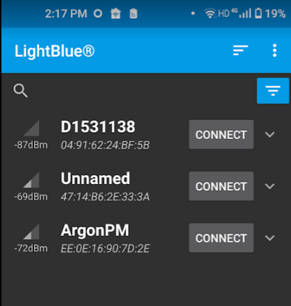

Connecting to it you can see that the advertising serviceUUid Is the same as we set.

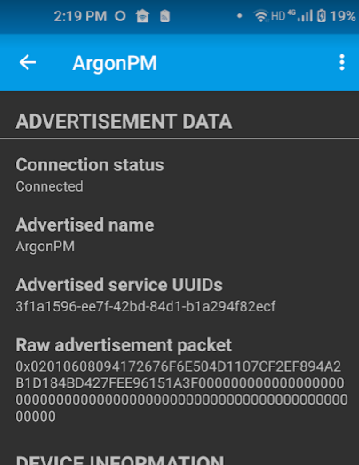

And scrolling down to the bottem we see the Characteristics.

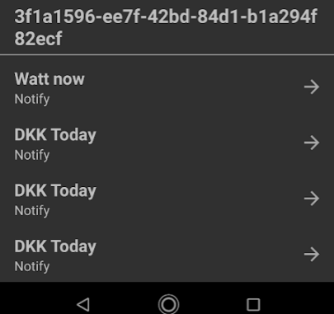

Next we can look at the Watt characteristic below.

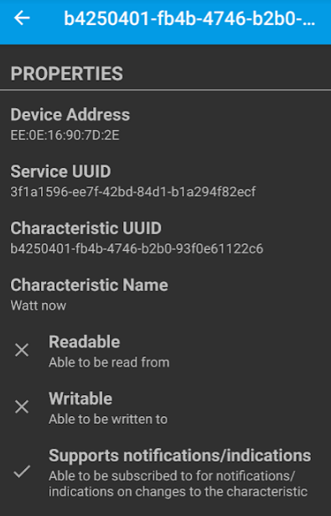

And if we want to snoop on what data is being sent we can subscribe to the characteristic.

The data format can be set all after what we are receiving.

I suggest we use Json strings to send that data.

The data below shows for sending a uint8_t . and it gets more complicated on the receiving end then one would like. Using the Arduino_json lib would help here.

